How to do:
for Integrate a module radio in chirp

Download the lasted chirp version, at :
https://chirp.danplanet.com/projects/chirp/wiki/Download
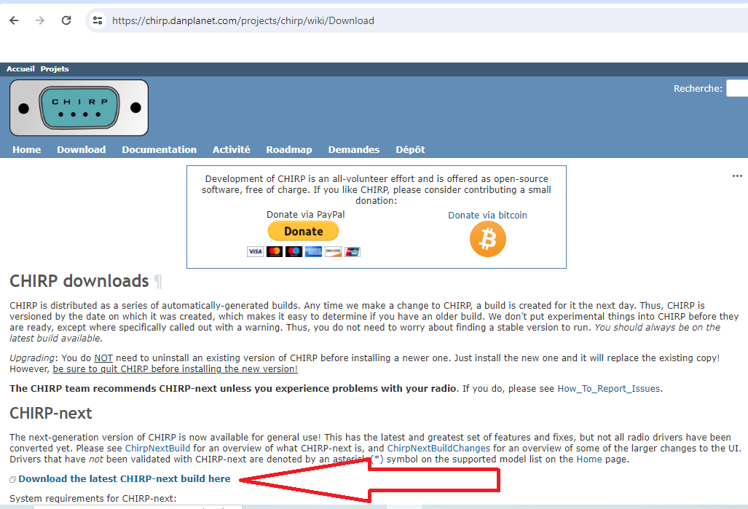

Install chirp, then open chirp.

This has to be done only once. ( To enable the development mode in chirp )
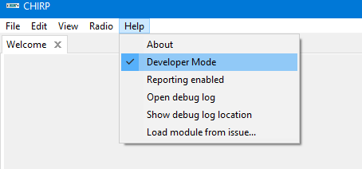

Go in Help menu and select the Developer Mode

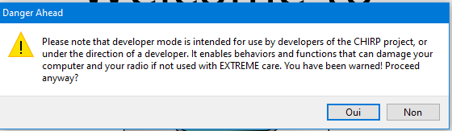
A warning message will pop-up, accept it,

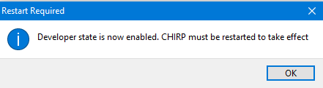
Close chirp and restarted chirp to enable the development mode as chirp request it.

TO LOAD THE MODULE DRIVER IN TO CHIRP

Download the file UVK5_EGZUMER_F4HWN.PY from web page F4HWN :
https://github.com/armel/uv-k5-chirp-driver
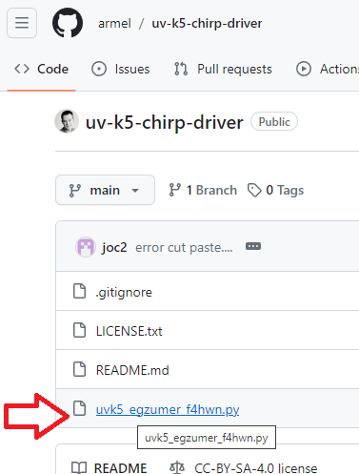

Click on the file UVK5_EGZUMER_F4HWN.PY

Then click on download the Raw file
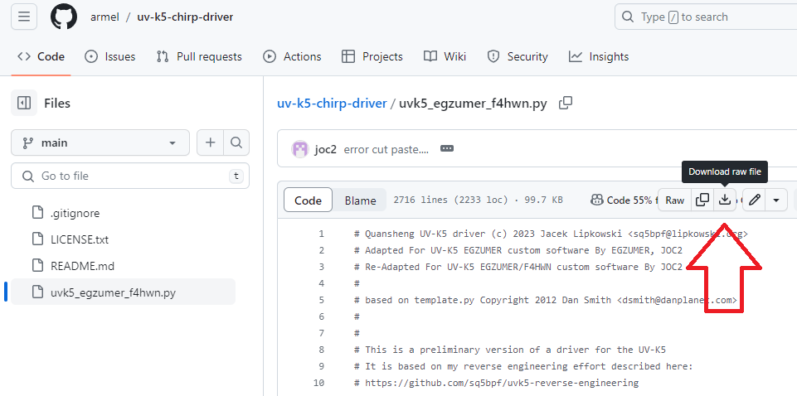

It will start to download, then save it, on your computer in the download location.

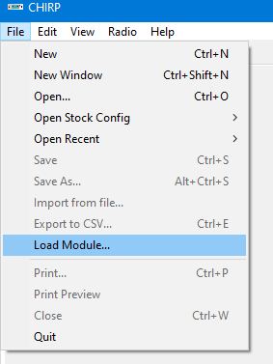
Go in chirp, open File menu and select Load Module... ( this menu is see only if the development mode is activated in chirp )

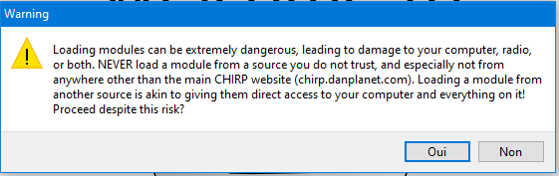
A warning message will pop-up
click yes,

Go select the file UVK5_EGZUMER_F4HWN.PY that it save on your computer in the download location, this has you previously done. The click Open
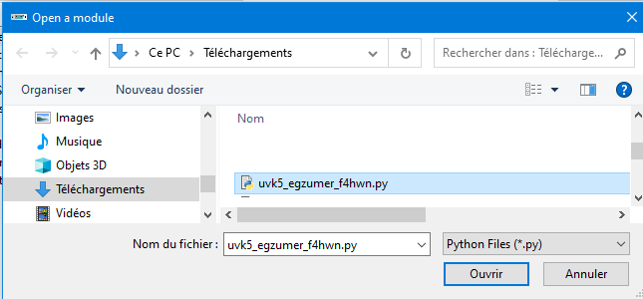

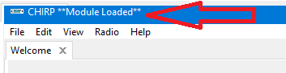
On the top windows title of chirp, a message **Module Loaded** will show up, that mean that the module has been correctly load in chirp

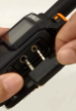
Now turn ON the radios that have F4HWN firmware, ( Just turn the knob, without pressing any key... ) when radio is ready, connect the programming cable in the radio ,

WARNING: be sure to push the connector well in to the radio, on some connector, it need to trim a little bit the plastic case of the programming cable to be able to push it completely

Example of programming cable:
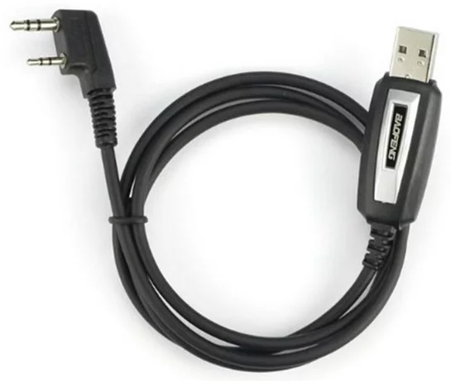

Connect the other end of the programming cable in your computer. Windows should detect and install the driver automatically and assign a communication port number.
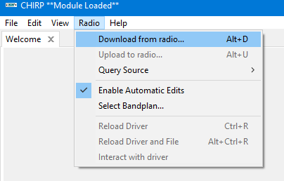
In chirp, go in menu Radio, select Download from radio... to read all the data from the radio to chirp

In the windows Communication with the radio.
1: Select the communication Port where is the programming cable is connected on the computer,
in my example, it’s COM3,
2: Select the Vendor. (Quansheng),
3: Select the Model
4: Their will be 2 menu UV-K5, the original From Chirp and the new one for F4HWN,
select the UV-K5 (egzumer + f4hwn)
5: click OK
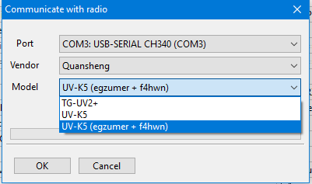

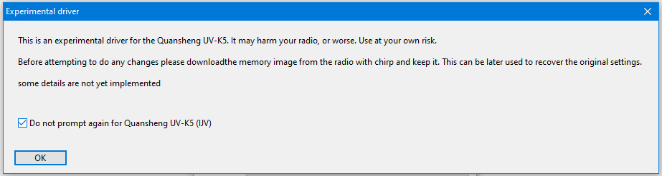
A warning message from chirp will pop-up, select the do not prompt again if you don't want to see it, each time you read the radio. Click OK

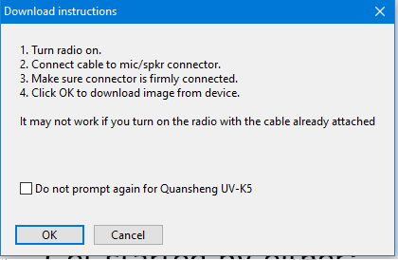
A download instruction window will pop-up

select the Do not prompt again... to not see this message again when download from this radio Model, then Click OK

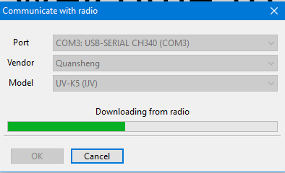
The communication with the radio will start downloading the data radio to the computer, wait to the end.

A new tab will show up, Quansheng_UV-K5 (egzumer + f4hwn) with all the data read from the radio.
The data in tab Memories and Settings can be change. In the tab Browser and Info it can be view only and uses mostly for development mode.
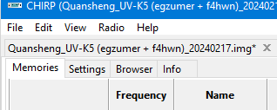

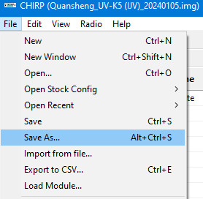
Now, save the reading of the radio as a reference, if you want in menu File then Save or Save As...

Make the modification you want, save the modification if you want to keep the data.

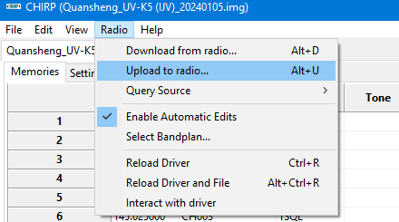
When ready to send the data to the radio, go in menu Radio and select Upload to Radio...

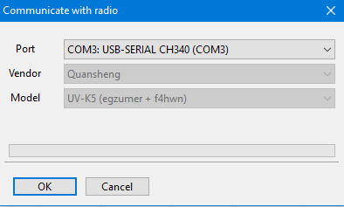
A Window Communication with radio will pop-up, but now, it’s just the Port can be selected, as the Vendor and Model is know, click OK to start uploading to the radio

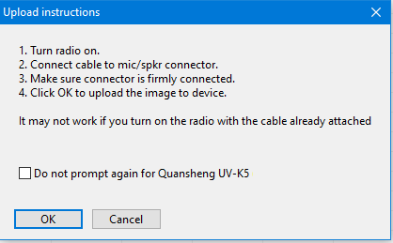
A window Upload instructions will pop-up

select the Do not prompt again... to not see this message again when Upload from this radio model, if you want, then click OK

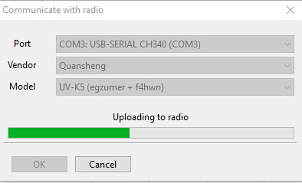
The windows Communication with radio will start to Uploading the chirp data to the radio, wait to the end.

When Complete, the radio will reboot it self. Then the radio is ready for uses with your new data.

Disconnect the programming cable.

Enjoy your new programming.

Calibration Upload

This section of memory need to be uses with care, if not may brake your radio. !!!!

To send all the calibration setting and only the calibration setting will be sent. You need to select this box.
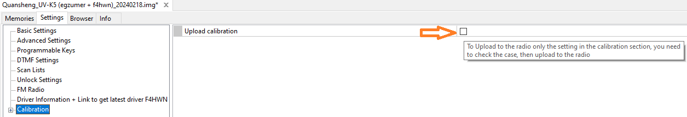
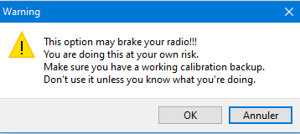
A warning message will pop-up, read it , and if you agree, click OK.

Make the modification you want to do, When ready to send the data to the radio, go in menu Radio and select Upload to Radio...

Select the Port, then click OK

The windows Communication with radio will start to Uploading the chirp calibration to the radio, it will be quick.

When finish, uncheck the box Upload Calibration.

F4HWN Upload

All the setting for F4HWN need to be sent separately to the radio.

The F4HWN setting are locate in the menu Basic Setting, on the first section.
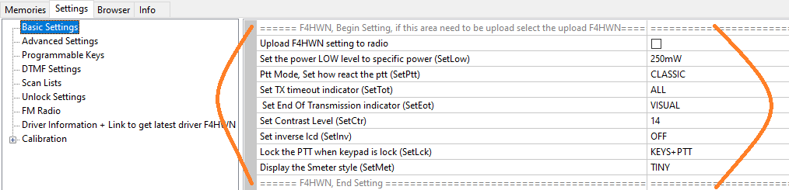
Make the modification setting you want , when ready to send all the F4HWN setting and only the F4HWN setting will be sent. You need to select this box.
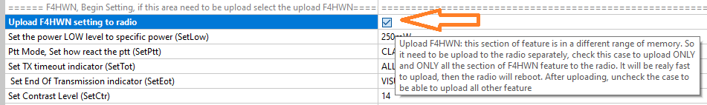
Make the modification you want to do, When ready to send the data to the radio, go in menu Radio and select Upload to Radio...

Select the Port, then click OK

The windows Communication with radio will start to Uploading the chirp calibration to the radio, it will be quick.

When finish, uncheck the box Upload F4HWN.

How to Change CHIRP Language

To force chirp in english, you need to change the windows parameter, because chirp select the language from it. First close Chirp. Then in Windows Menu
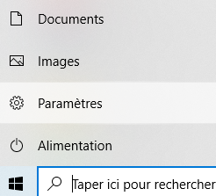
Go in Parameter

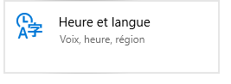
Go select Time and Language

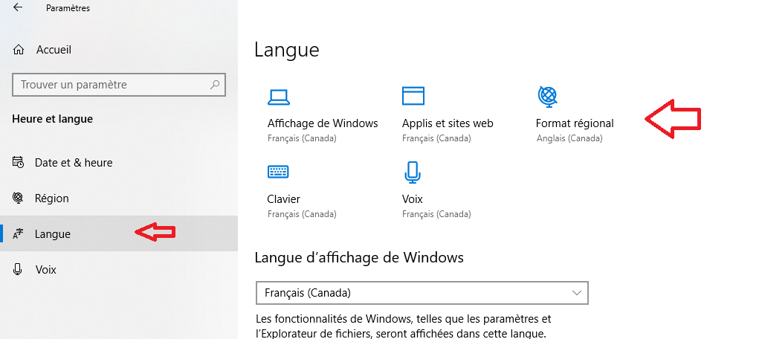
then, select language
then Regional Format

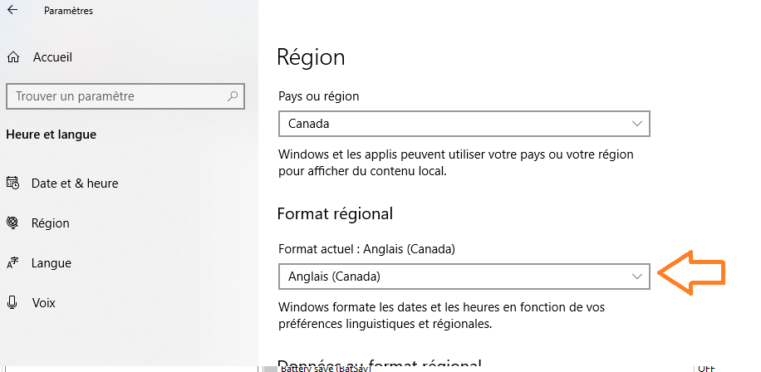
In the Regional format go select english

Now,Start Chirp, it will display it in english.

Enjoy.

